Object Complement as a Verb Complement

✅ What Is an Object Complement?
# Source: AI Source: Provided by: [Data Path: Persons Table -> ID Column: 1, Name_En Column: Motasem Essam] -> From: [ChatGPT] on [8/4/2025]
An object complement is a word or phrase that follows and modifies or renames the direct object, completing the meaning of the verb. In some contexts, it acts as a verb complement because it helps complete the verb's idea by elaborating on the object.

🔸 Structure:
# Source: AI Source: Provided by: [Data Path: Persons Table -> ID Column: 1, Name_En Column: Motasem Essam] -> From: [ChatGPT] on [8/4/2025]
- Verb + Direct Object + Object Complement
- Common after verbs like: make, name, elect, consider, find, call, appoint, etc.

🔸 Examples:
# Source: AI Source: Provided by: [Data Path: Persons Table -> ID Column: 1, Name_En Column: Motasem Essam] -> From: [ChatGPT] on [8/4/2025]
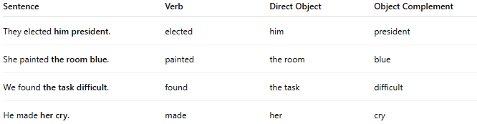
Sentence | Verb | Direct Object | Object Complement
They elected him president. | elected | him | president
She painted the room blue. | painted | the room | blue
We found the task difficult. | found | the task | difficult
He made her cry. | made | her | cry

🔸 Why It's a Verb Complement:
# Source: AI Source: Provided by: [Data Path: Persons Table -> ID Column: 1, Name_En Column: Motasem Essam] -> From: [ChatGPT] on [8/4/2025]
The object complement completes the action expressed by the verb by describing the result, identity, or state of the object. Without it, the verb’s meaning may be unclear or incomplete.
🟢 Example:
- ✅ "They elected him president."
- ❌ "They elected him." (grammatical but semantically incomplete — elected him as what?)

